k
Object Orientend Programming
with C++
(
CSE
-2001)
PRACTICAL FILE
Name : Adhikari Viswa Teja
Reg n.o : 24MIM10138
Submitted to : Dr. Dhereesh Soni
Slot :A11+A12+A13
Introduction to
Problem Solving
(
CSE
1021)
Project Title
Library Management
System

Name : GUNTA KARTHICK REDDY
Reg n.o : 26MIM10020
Submitted to : DR.Pricilla Dinkar moya
Slot :B11+B12+B13+C14+E11+E12

1.Introduction
The Movies & Shows Management System is a Python-based console application designed to organize and manage personal entertainment content. Users can add movies, add TV shows, search, delete, and mark items as watched. The system uses JSON storage for persistent data.
The project demonstrates Python fundamentals such as functions, conditionals, loops, and file handling.

2. Problem Statement
.People often struggle to keep track of what movies and shows they have watched, plan to watch, or want to remember later. There is no simple offline system for maintaining lists, checking watch status, or organizing content.
This project solves this problem by creating a simple, menu-driven management tool.

3. Functional Requirements
Add Movie
Add Show
View all items
Mark as watched
Delete item
Search by title keyword
Save and load data using JSON
User-friendly menu interface

4. Non-Functional Requirements
Usability: Simple and intuitive CLI menu
Reliability: Data stored in JSON format persistently
Portability: Works on Windows, Linux, Mac, and Android (Pydroid/Termux)
Performance: Fast response, low memory usage
Scalability: Easy to add future

5. System Architecture
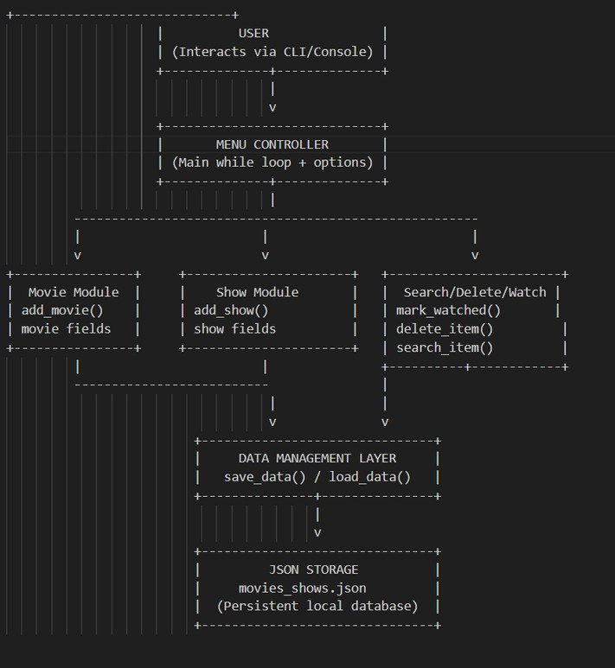

7. Design Diagrams
a) Use Case Diagram 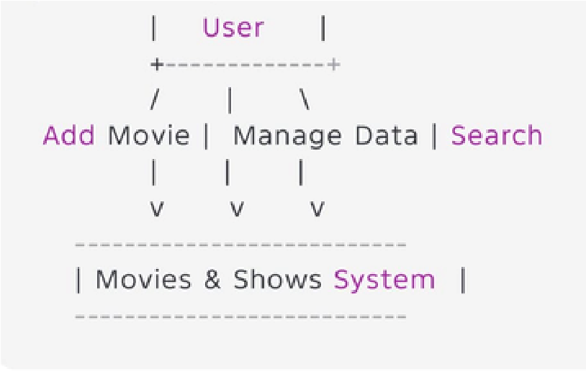

b) Workflow Diagram
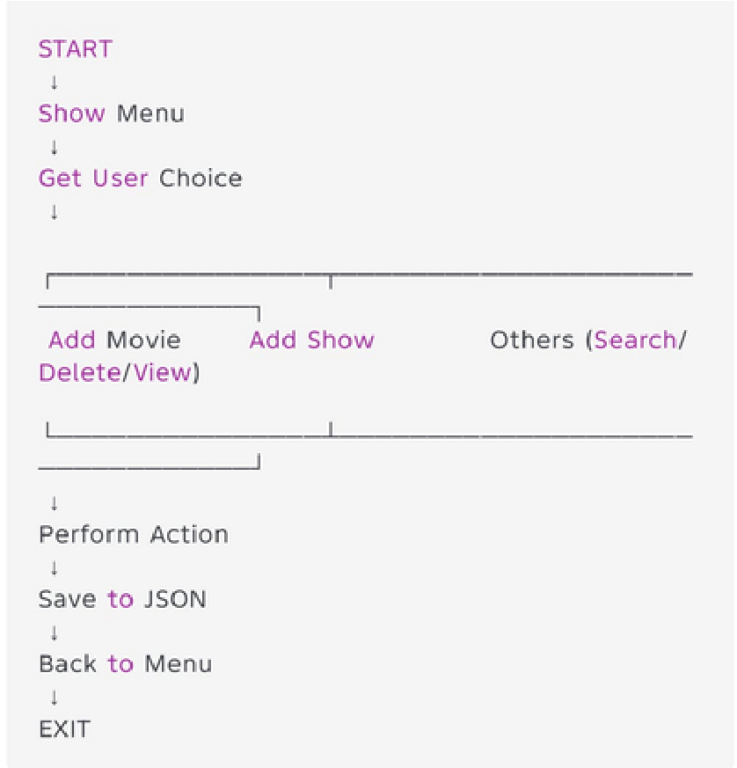

c) Sequence Diagram
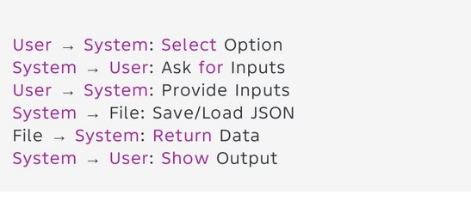

d) Class/Component Diagram
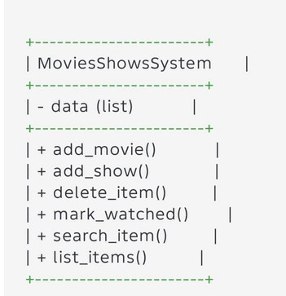
e) ER Diagram (if storage used)
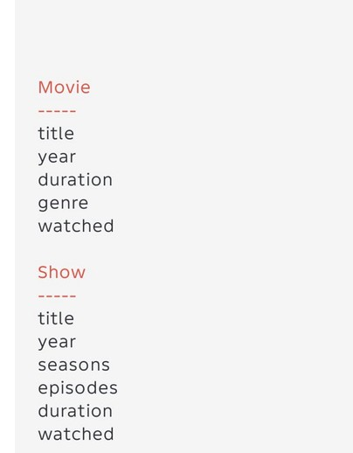
8. Design Decisions & Rationale
JSON file chosen for simple persistent storage
Functions used to modularize code
Menu-based design for ease of use
Separate Add Movie & Add Show for flexibility
Dictionary-based data structure for structured attributes

9. Implementation Details
Written in Python 3
Uses json module for file handling
Lists & dictionaries store movie/show information
While loop used for menu operations
Status updates (watched/pending) stored as boolean values

10. Screenshots / Results
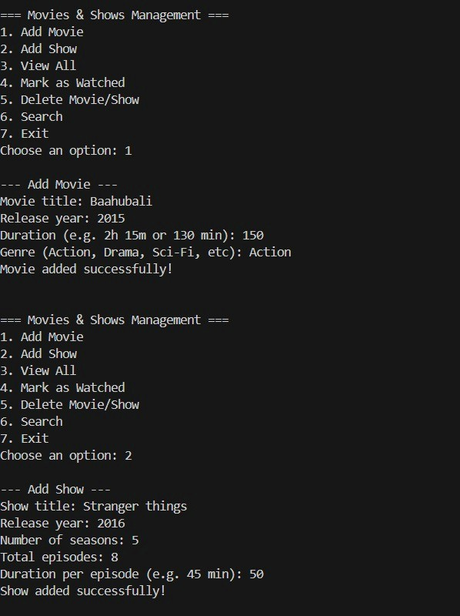

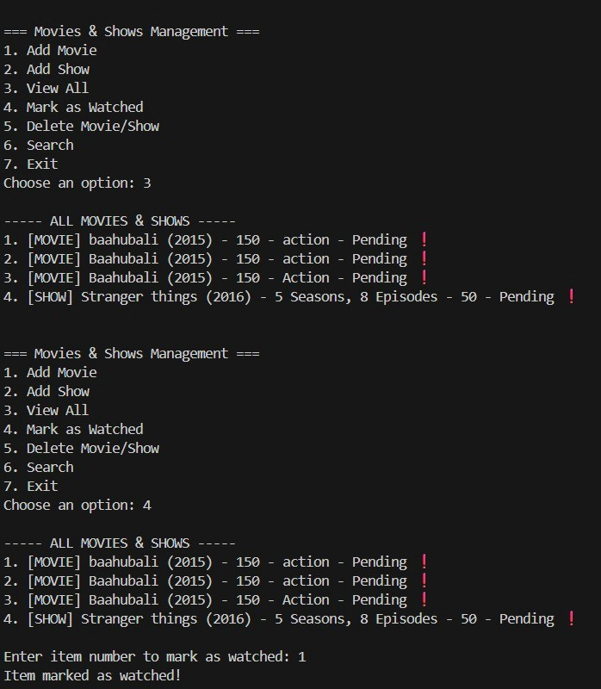

11. Testing Approach
Input Testing: Checked with valid/invalid inputs
Search Testing: Verified partial keywords
Delete Testing: Verified deletion of movies and shows
JSON File Testing: Ensured reading and writing works
Boundary Testing: Empty list, 1 item, multiple item

12. Challenges Faced
Handling JSON data formatting
Designing a clear and simple menu
Managing separate structures for movies and shows
Keeping the code modular and readable

13. Learnings & Key Takeaways
Understanding of JSON-based storage
Importance of modular programming
Real-world data structuring using dictionaries
Python file handling and loops
Project documentation and design diagrams

14. Future Enhancements
Add OTT platform (Netflix, Prime, Hotstar)
Add IMDB rating system
Add sorting & filtering (Year, Genre, A–Z)
Export data to Excel/PDF
Tkinter GUI version
Movie recommendations based on genre

15. References
Python Official Documentation (python.org)
W3Schools Python Reference
GeeksForGeeks – JSON Handling
Class lecture notes

